Table of Contents

1. Quick Start 2

2. Understanding the User Interface 3

2.1. List Pane 3

2.2. Message bar 5

2.3. Command Bar 5

3. Feature Details 6

3.1. Add tasks 6

3.2. Delete tasks 8

3.3. Update tasks 8

3.4. Postpone tasks 9

3.5. Search tasks 10

3.6. Reserve tasks 10

3.7. Confirm timeslot 11

3.8. Mark as done/undone 11

3.9. Change storage location 12

3.10. Undo/Redo 12

3.11. Help Screen 13

3.12. Exit 13

4. Cheat Sheet 13

4.1. Summary of Commands 13

4.2. List of Task Group, Preposition, Time Group 15

User Guide

# Quick Start

**Step 1:** Install and configure Java environment on your computer. You can download JDK [here](http://www.oracle.com/technetwork/java/javase/downloads/index.html) or copy paste <http://www.oracle.com/technetwork/java/javase/downloads/index.html> onto your web browser.

**Step 2**: Download J.Listee.jar from [GitHub](https://github.com/cs2103jan2016-t15-2j/main).

**Step 3**: Double-click on the jar file to run the application.

**Step 4:** Try to type the following commands in the command box and see what’s happening:

add my first task @icube #cs2103 from today 4pm to 6pm (enter)

update 1 updated first task (enter)

done 1 (enter)

**Step 5**: Now you can add more tasks and get ready to enjoy your life in order!

**Step 6:** Proceed on to type “help” if you should require any assistance!

# Understanding the User Interface

## List Pane

The first part is the list pane which displays lists of tasks.

On startup, J.Listee will show you overdue tasks, today’s tasks, untimed tasks and reserved tasks, automatically ordered by time within each group.

* + 1. 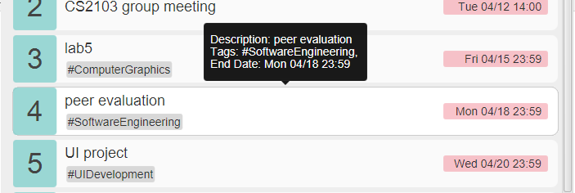Tasks

The list pane contains blocks of tasks.

You can use **arrow keys** (↑ and ↓) or click to focus a specific task when the command bar is not focused. The focused task will be highlighted and a tooltip containing all of the task’s information will appear. The focused task can then be managed using keyboard shortcut, which will be detailed in Feature Details.

* + 1. 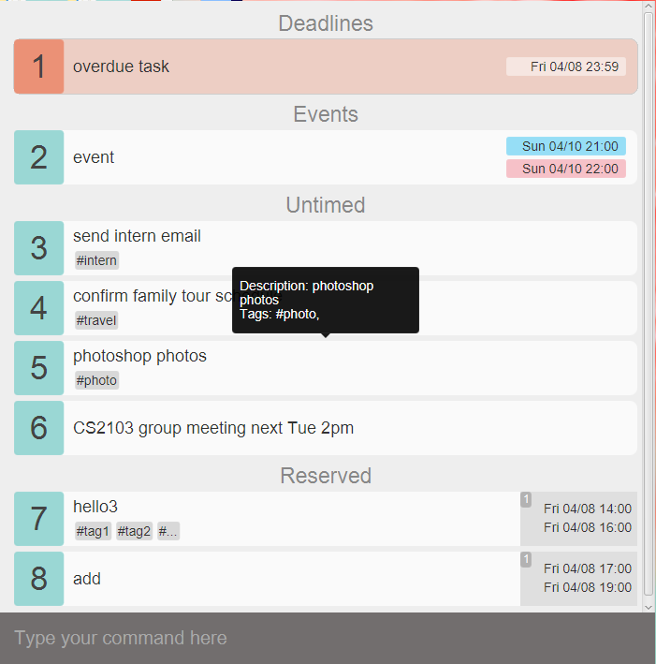Overdue tasks

Overdue tasks will be colored in red to remind you. And they are constantly synchronized by J.Listee, which means as soon as a task becomes overdue, you will immediately be reminded!

* + 1. Conflict tasks

When you input a time that clashes with other tasks, the conflicted tasks will blink for a while to capture your attention and serve as a warning.

## Message bar

Every time you make some operations, the message bar containing feedback 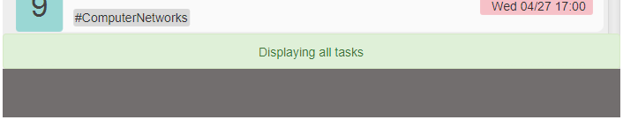messages will be automatically triggered and disappear after a while.

## Command Bar

The command bar is where you type your command and tell J.Listee what to do next.

You can use **arrow keys** (↑ and ↓) to retrieve previous or later commands you have entered when the command bar is focused. Usually when an operation is made, the focus will be on some tasks in the list pane. Then you can **press space bar** to focus command bar again and type your next command.

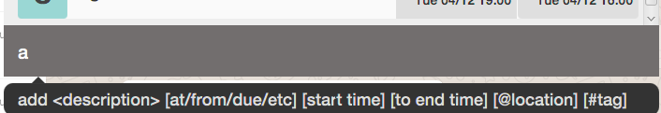When you are typing in the command bar, command suggestion will be shown. So follow them if you forget the command format!

# Feature Details

These are a few notes for the features:

< > represents compulsory input

[ ] represents non compulsory

@ represents location

# represent hashtags

Refer to list of preposition, timegroup, taskgroup here.

## Add tasks

This command enables you to add a task into J.Listee. The task will be assigned a task number when listed to you. After adding the task, the list of all tasks will automatically be displayed in the current page.

* + 1. Add untimed tasks

|  |
| --- |
| **add wash clothes some time @home #laundry #sigh** |

**Format:**

<add> <description> [@location] [#tags]

**Must-have arguments:**

Task description

**Optional arguments:**

location, tags (tags cannot contain whitespace)

**Remarks:**

Task Description, location, tags can be inserted in random order such as   
add @home #sigh wash clothes #laundry

* + 1. Add deadline tasks

|  |
| --- |
| **add watch BigBang Theory this Monday @mac-common** |

**Format:**

<add> <description> <<preposition> time> [@location] [#tags]

**Must-have arguments:**

Task description, deadline time

**Optional arguments:**

location, tags (tags cannot contain whitespace)

**Remarks:**

Task Description, location, tags and time can be inserted in random order such as :  
add this Monday @ mac-common watch BigBangTheory, note that the last preposition will then be date

* + 1. Add event tasks

|  |
| --- |
| **add Bali Travel from 4/16 2pm to 4/20 4pm @Bali #travel** |

**Format:**

<add> <description> <<from> start time <to>end time> [<@>location][#tags]

**Must-have arguments:**

Task description, start time, end time

**Optional arguments:**

location, tags (tags cannot contain whitespace)

**Remarks:**

Task Description, location, tags and time can be inserted in random order such as :   
add this Monday @ mac-common watch BigBangTheory.

Note that the last index of “from..to..” will then be read in as date

## Delete tasks

This command enables you to delete existing tasks from J.Listee.

For example, if you want to delete task 1, 2, 3 and 5, you can try the following:

|  |
| --- |
| **del 1-3, 5** |
| **delete 1,2,3, 5** |

**Format:**

<delete> or <del> <starting task number - ending task number>

<delete> or <del> <tasknumber, tasknumber, tasknumber>

**Must-have arguments:**

at least one task number

**Optional arguments:**

more task number separated by English comma or linked by minus

**Shortcut:**

Select the specific task and press Backspace or Delete, the task will be deleted.

## Update tasks

This command enables you to update an existing task in J.Listee.

3.3.1 Update tasks that is not reserved

|  |
| --- |
| **update 2 more work +end tonight 2359** |

Update the 2nd task’s description to “more work” and change end time to “tonight 2359”

**Format:**

<update> / <edit> <task number> [+ OR - <timegroup> time] [task description] [@location] OR [-@] [#hashtags][-#deletehashtags]

**Must-have arguments:**

a task number indicating the specific task

**Optional arguments:**

new task description, removing start time, new start time, new end time, removing existing location OR new location, removing specific tags, new tags

3.3.2 Update reserved tasks

|  |
| --- |
| **update 3 2 +start today 4pm** |

Update the 3rd task, 2nd time slot’s start time to “today 4pm”

**Format:**

<update> <task number > [<reservation index> < [-] OR [+] timegroup [time]> [task description] [@location] OR [-@] [#hashtags][-#deletehashtags]

**Must-have arguments:**

a task number indicating the specific task, a reservation index indicating the specific time slot reserved

**Optional arguments:**

new task description, new start time, new end time, removing existing location OR new location, removing specific tags, new tags

## Postpone tasks

This command enables you to postpone the deadline of an existing task for some minutes, hours, days, months, years.

|  |
| --- |
| **postpone 3 3years 2months 8days** |

**Format:**

<postpone> <task number> <time>

**Must-have arguments:**

a task number indicating a specific task, time

**Shortcut:**

Select the specific task and press p, the deadline of the task will be postponed for 1 day.

## Search tasks

This command enables you to see specific tasks in a time period or with some specific information.

|  |
| --- |
| **show /today @school assignment** |

Which means to show today’s task at school with the keyword assignment

**Format:**

<show> [task description] [/taskgroup] [<preposition> time] [@location] [#hashtags]

**Must-have arguments:**

some filter

## Reserve tasks

This command enables you to reserve multiple time slots for later use.

|  |
| --- |
| **reserve meet friends from thurs 4pm to Thursday 6pm or friday**  **4pm to 6pm #dinner** |

Which means to the reserved “meet friends” task will have 2 timeslots, one from Thusday 4pm to 6pm, the other from Friday 4pm to 6pm

**Format:**

reserve <task description> <<from> start time <to> end time> [<and/or> <from> start time <to> end time] [@location] [#hashtags]

**Must-have arguments:**

Task description and at least one timeslot

**Optional arguments:**

more timeslots linked by and/or

## Confirm timeslot

This command enables you to confirm one of the time slots you have reserved.

|  |
| --- |
| **confirm 2 3** |

Which means to confirm the 3rd reserved timeslot of the 2nd task

**Format:**

<confirm> <task number> <reservation index>

**Must-have arguments:**

a task number indicating the specific task and the index of a timeslot reserved

**Shortcut:**

Select the specific task and press the number key, and the corresponding timeslot of the task will be confirmed.

## Mark as done/undone

This command enables you to mark existing tasks as done/undone. The completed tasks will then disappear from the current page. You can type “show /done” to see the tasks just marked as done.

|  |
| --- |
| **undone 1-3,5** |

Which means to mark 1, 2, 3, 5 as undone (the tasks must be completed at the first place)

**Format:**

<done> <starting task number - ending task number>

<done> <tasknumber, tasknumber, tasknumber>

**Must-have arguments:**

at least one task number

**Optional arguments:**

more task number separated by English comma or linked by minus

**Shortcut:**

Select the specific task and press d, if the task is completed, it will be marked as undone, otherwise it’ll be marked as done.

## Change storage location

This command enables you to change the storage location to the folder you want. After entering this command, a folder choosing window will pop up, and you can choose the folder you want to put the file in.

|  |
| --- |
| **change filepath** |

**Format:**

change filepath

**Shortcut:**

Press ctrl+f to pop up the folder chooser.

## Undo/Redo

This command enables you to undo or redo the most recent operation.

|  |
| --- |
| **redo** |

**Format:**

undo/redo

**Shortcut:**

Press ctrl+z to undo last operation; Press ctrl+y to redo last undid operation

## Help Screen

This command enables you to see help screen.

|  |
| --- |
| **help** |

**Format:**

help

**Shortcut:**

Press ctrl+h to see help screen.

## Exit

This command enables you to exit from J.Listee.

|  |
| --- |
| **exit** |

**Format:**

exit or quit

**Shortcut:**

Press Escape to exit.

# Cheat Sheet

## Summary of Commands (in alphabetical order)

|  |  |  |  |
| --- | --- | --- | --- |
| **Command Type** | **Command** | **Format** | **Example** |
| add deadline | add | add description [<preposition> time] [@location] [#tags] | add good friday this friday  @home #yay #study |
| add event | add | add description from start time to end time [*@*location] [#tag] | add meeting with prof @com1 #work from 1st april 2pm to 5th april 3pm |
| add untimed task | add | add description [@location] [#tags] | add @room clean |
| change a filepath for txt file | change filepath |  |  |
| confirm a reserve task starting from left most as index 1 | confirm  cfm | confirm tasknumber reserve task index | confirm 2 3 |
| delete task | delete  del | <del> or <delete> <starting task number - ending task number>  <del> or <delete> <tasknumber, tasknumber, tasknumber> | delete 1-3, 5  delete 1,2,3,4,5  delete 1-5 |
| done task | done | <done> <starting task number - ending task number>  <done> tasknumber, tasknumber, tasknumber> | done 1-3, 5  done 1,2,3,4,5  done 1-5 |
| edit other task (not reserved) | update  edit | <update> <task number > [</timegroup> time] [task description] [@location] OR [-@] [#hashtags][-#deletehashtags] | update 2  more work /end tonight 2359  edit 2 /both today from 3pm to 6pm -@ |
| edit reserve task | update  edit | <update> <task number > [<reservation index> <[-]/timegroup [time]> [task description] [@location] OR [-@] [#hashtags][-#deletehashtags] | update 1 1 /start today 4pm  edit  2 meeting manager @office  edit 3 -start |
| exit from app | exit  quit |  |  |
| help screen | help |  |  |
| postpone a task | postpone  pp | <postpone> <task number> <<time>> | postpone 1 2year  postpone 2 2hours 4mins  postpone 3  3years 2months 8days |
| redo previous command | redo |  |  |
| reserve multiple slots of time | reserve  res | reserve <task description> [<from> start time <to> end time] [and/or] [<from> start time <to> end time] [@location] [#hashtags] | reserve meet friends from thursday 4pm to thursday 6pm or friday 4pm to 6pm #dinner |
| search for a certain group of task, particular location or hashtag | show  search | <show> [task description] [/taskgroup][<preposition> time] [@location] [#hashtags] | show  assignment due friday  or  show /today @school assignment |
| undo previous command | undo |  |  |
| undone a done task | undone | <undone> <starting task number - ending task number>  <undone> tasknumber, tasknumber, tasknumber> | undone 1-3, 5  undone 1,2,3,4,5  undone 1-5 |

## List of Task Group, Preposition, Time Group

|  |  |  |
| --- | --- | --- |
| **Task group for show / search** | **Prepositions before time** | **Time group for update** |
| /today | from…to…. | +end |
| /tomorrow | by | +start |
| /overdue | on | +etime |
| /done | at | +stime |
| /reserved | due | -alltime |
| /events | during | -end |
| /deadlines | in | -start |
| /untimed | for | +both |
|  | this |  |
|  | before |  |
|  | after |  |
|  | next |  |